Step 1
open http://remix.ethereum.org
Step 2.
add plugins:
Compiler and Deploy and run Transaction
Step 3.
Add KYC.sol file to the files structure
Step 4.
open compiler panel on left
change compiler version to 0.5.17
click on compile KYC.sol to compile the contract
Step 5.
Once the compilation is successful, i.e. you see a green tick on compiler icon,
open Deployment and Run Transaction panel on left

1.Select Environtment as JavaScriptVM
2.Select any one account value, REmix provides a default list of account addresses on blockchain
3. set GAS LIMIT to 300000000 or more
4. Select KYC.sol as the contract file

Under Deployed Contact, you see that the KYC contract is deployed.
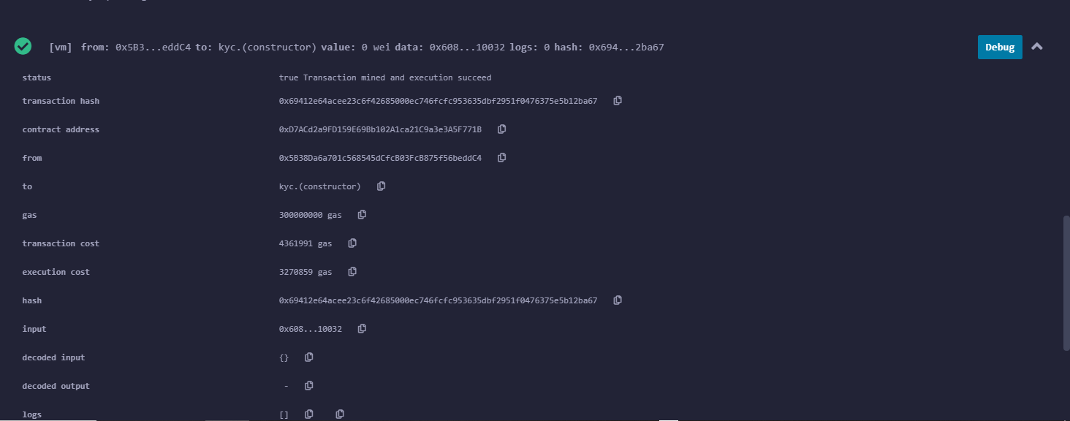

Testing functions of KYC contract:

ADMIN Specific functions:

1. addBank():
PASS Test:
1.
- Copy one of the addresses(except the one that created the contract) from the list of ACCOUNTS and add it as bankAddres, name as you like; bankRegNum, any string value:

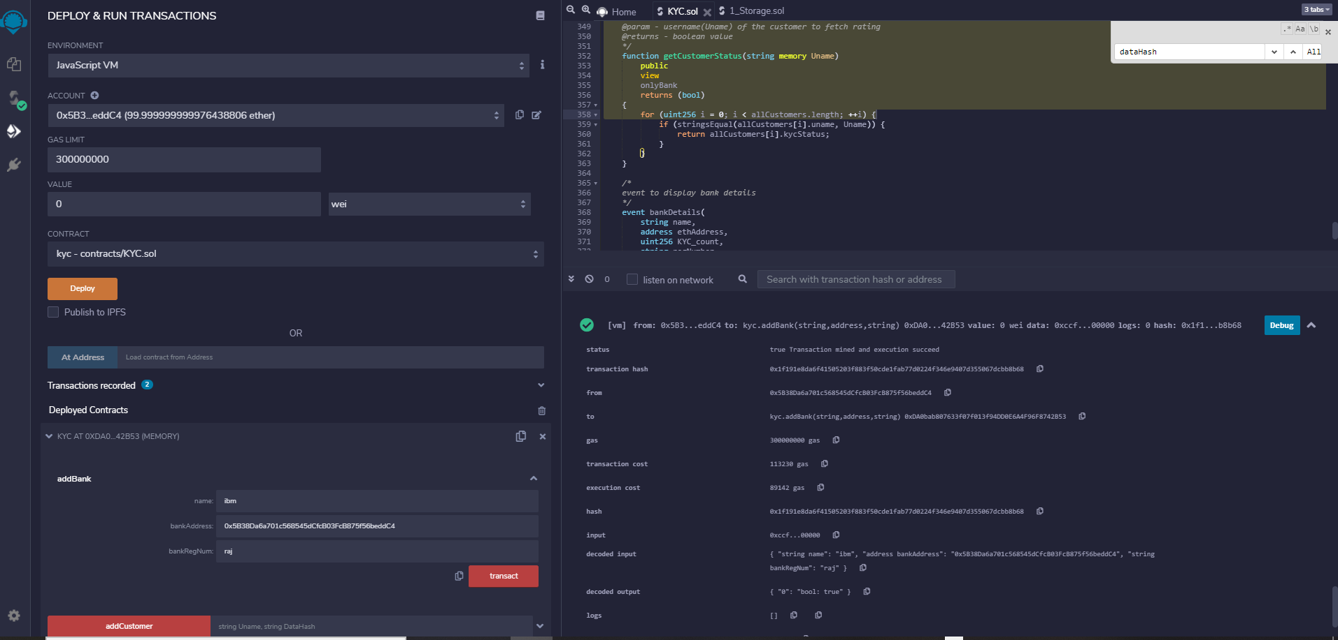

- You can check the console by expanding transaction info,
  - decoded output:
{ "0": "bool: true" }
Proves that bank is added
2.
- Add another bank with the same bankAddress as the previous one, the output is false, as Bank id already present in the list of banks.

FAILURE Test:
- Change sender address to Bank address(the one created in previous step)
and try to add another bank. An Error as below is returned:

transact to KYC.addBank errored: VM error: revert. revert The transaction has been reverted to the initial state. Reason provided by the contract: "Only admin can perform this action". Debug the transaction to get more information.

2. removeBank():
1. PASS Test:

1. Change ACCOUNT address to admin address and try to remove bank added previously:

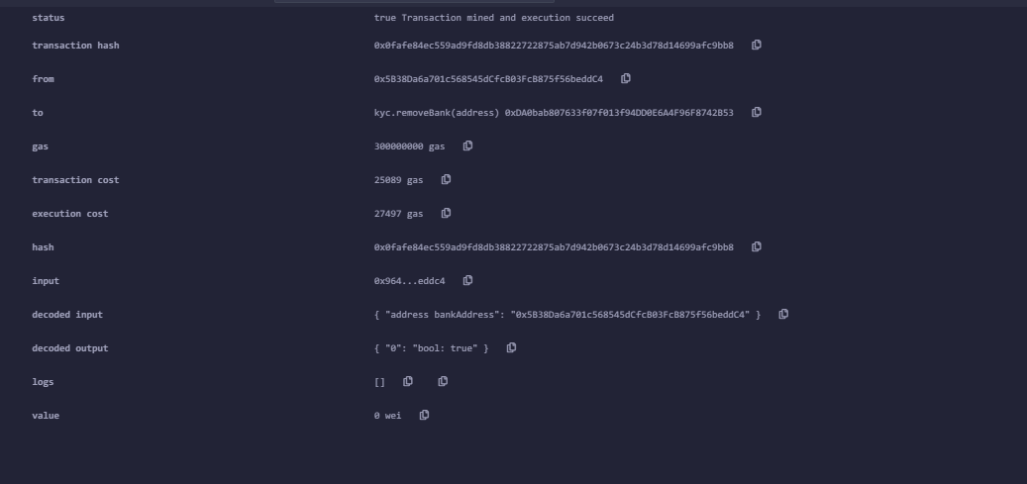
output is true indicating that bank has been removed from the list of banks

2. Try to remove a bank that is not present in the network:
pass invalid address as argument as admin, it should return false as output. Since the bank is not present in the list, it cannot be removed.

Specific Functions:

In order to implement bank functions, add 10 banks to the network.

Following are the functions that you need to write in your smart contract. These are the functions that a bank can call.
- Add Request - This function is used to add the KYC request to the requests list. If kycPermission is set to false bank won’t be allowed to add requests for any customer.
  - Parameters - Customer name as a string and hash of the customer data as a string.
- Add Customer - This function will add a customer to the customer list. If IsAllowed is false then don't process the request.
  - Parameter - Customer name as a string and data of the customer data as a string.
- Remove Request - This function will remove the request from the requests list.
  - Parameters - Customer name as string and hash of the customer data as a string.
- Remove Customer - This function will remove the customer from the customer list. Remove the kyc requests of that customer too. Only the bank which added the customer can remove him.
  - Parameters - Customer name as string.
- View Customer - This function allows a bank to view details of a customer.
  - Parameters - Customer name as string.
  - Return - Customer name and data as string.
- Upvote customers - This function allows a bank to cast an upvote for a customer. This vote from a bank means that it accepts the customer details as well acknowledge the KYC process done by some bank on the customer.
  - Parameters - Customer name as string.
- Downvote customers - This function allows a bank to cast an downvote for a customer. This vote from a bank means that it does not accept the customer details.
  - Parameters - Customer name as string.
- Modify Customer - This function allows a bank to modify a customer's data. This will remove the customer from the kyc request list and set the number of downvote and upvote to zero.
  - Parameters - Customer username and data as string.
- Get Bank Reports- This function is used to fetch bank reports from the smart contract.
  - Parameters - Bank address is passed as address to fetch bank ratings.
  - Return - Integer number of reports against the bank.
- Get Customer Status - This function is used to fetch customer kyc status from the smart contract. If true then the customer is verified.
  - Parameters - Customer username as a string.
  - Return - Boolean
- View Bank Details (Unique Identifier for the Bank) - This function is used to fetch the bank details.
  - Parameters - Bank address is passed to the function.
  - Return - The return type of this function will be of type Bank.

Admin Interface
Below are the functions specific to admin.
- Add Bank - This function is used by the admin to add a bank to the KYC Contract. You need to verify if the user trying to call this function is admin or not.
  - Parameters - Bank name as string, bank address as address and bank registration number as string are passed to the function “Add Bank”. Set number of reports initially to zero and kyc permission as allowed/true.
- Modify bank kycPermission - This function can only be used by the admin to change the status of kycPermission of any of the banks at any point of the time.
  - Parameters -Bank address
- Remove Bank - This function is used by the admin to remove a bank from the KYC Contract. You need to verify if the user trying to call this function is admin or not.
  - Parameters -Bank address as address is passed to the function “Remove Bank.”

Smart Contract Flow
- Bank collects the information for the KYC from Customer.
- The information collected includes User Name and Customer data which is the hash link for the data present at a secure storage. This username is unique for each customer.
- A bank creates the request for submission which is stored in the smart contract.
- A bank then verifies the customer KYC data which is then added to the customer list.
- Other banks can get the customer information from the customer list.
- Other banks can also provide upvotes/downvotes on customer data, to showcase the authenticity of the data. If the number of upvotes is greater than the number of downvotes then the kysStatus of that customer is set to true. If a customer gets downvoted by one third of the bank's kycStatus is changed to false even if the number of upvotes is more than downvotes. For such a logic there should be a minimum of 5 or 10 banks in the network.
- Banks can also report other banks if they find the bank to be corrupt and it is verifying false customers. Such corrupted banks then will be banned from upvoting/downvoting further . If more than one third of the total banks in the network report against a certain bank then the bank will be banned(i.e. Set kycPermission to false of that corrupt bank.)

